CLASSICS |  | ALLERGENS
Focaccia  VG. Fresh garlic and butter | 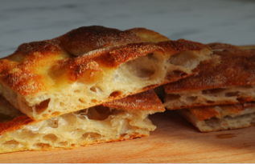 | Wheat (gluten)
Focaccia Rosemary  V. Rosemary and drizzle of olive oil | 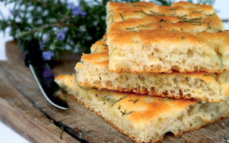 | Wheat (gluten)
Margherita  VG. San Marzano dop, fior di latte mozzarella, parmigiano and a drizzle of olive oil. | 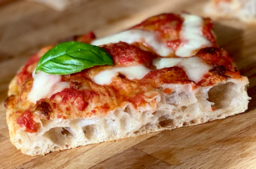 | Wheat (gluten), milk
Italian Salami  San Marzano tomatoes dop, fior di latte mozzarella, Italian salami | 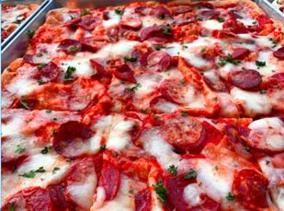 | Wheat (gluten), milk
Vegetarian  V. San Marzano tomatoes dop, fior di latte mozzarella, zucchini, peppers, red onions and cherry tomatoes | 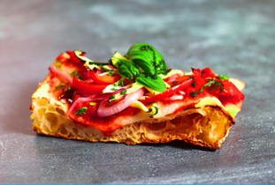 | Wheat (gluten), milk
Vegan  V. San Marzano tomatoes dop, zucchini, peppers, red onions with or without vegan cheese | 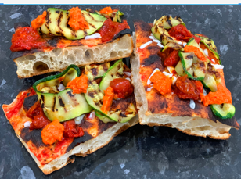 | Wheat (gluten)
Tuna & Red Onions  San Marzano tomotoes dop, fior di latte mozzarella, tuna and red onions | 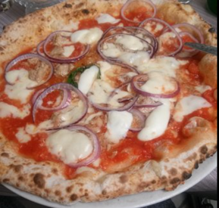 | Wheat (gluten), milk
Prosciutto Cotto (ham) & mozzarella  Pizza bianca (white- no tomatoes) with Italian ham, fior di latte mozzarella and oregano | 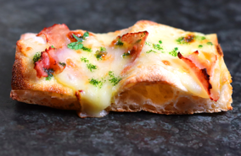 | Wheat (gluten), milk

GOURMET |  | ALLERGENS
N'duja & Ricotta  Spicy. N'duja = spicy sausage from Calabria Ricotta cheese For di latte mozzarella | 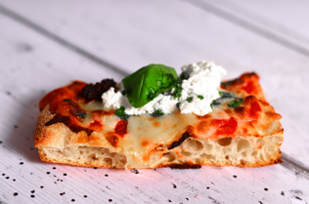 | Wheat (gluten), milk
Buffalo Mozzarella, Cherry tomatoes and Pesto  San Marzano Tomatoes dop Fior di latte mozzarella  Buffalo Mozzarella  Pesto alla Genovese | 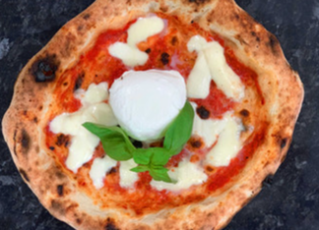 | Wheat (gluten),  Milk,  Cashewnuts and may contain traces of other nuts
Speck & Gorgonzola  San Marzano Tomatoes dop Fior di latte mozzarella Speck (smoky cured ham from South Tyrol) Reduction of Gorgonzola (blue cheese from Milan) | 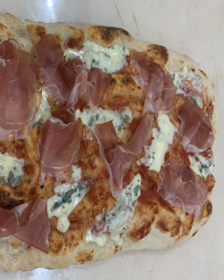 | Wheat (gluten), milk
Sun-dried Tomatoes, Spicy Salami & Jalapeños  Spicy. San Marzano tomatoes dop, fior di latte mozzarella, sun-dried tomatoes, spicy spianata Calabra & jalapenos | 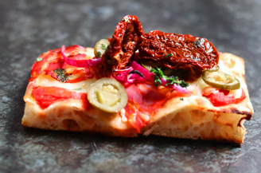 | Wheat (gluten), milk
Potatoes & Sausage  Pizza bianca (no tomato) potatoes, italian sausage & rosemary | 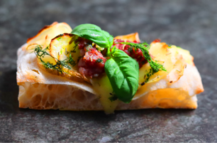 | Wheat (gluten), milk
Parmigiano & Parma Ham  San marzano tomatoes dop, fior di latte mozzarella, parmigiano and parma ham | 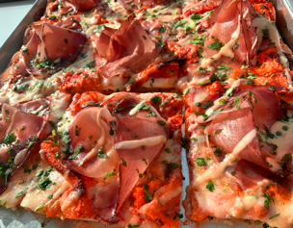 | Wheat (gluten), milk
Prosciutto Cotto, Stracciatella & Olives  San marzano tomatoes dop, prosciutto cotto ham, stracciatella (the creamy core of a burrata) and olives | 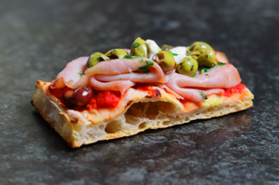 | Wheat (gluten), milk
Roman Artichokes, Parma Ham & Stracciatella  San marzano tomatoes dop, cherry tomatoes, parma ham, stracciatella (the creamy core of a burrata) and roman artichokes | 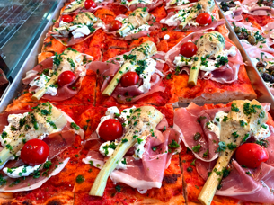 | Wheat (gluten), milk
Smoked Salmon, Burrata & Pink Peppercorn  San marzano tomatoes dop, burrata (creamy mozzarella), smoked salmon, herbs, lemon slice and pink peppercorn | 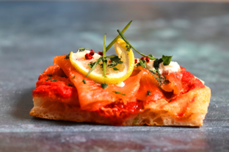 | Wheat (gluten), milk

PASTRIES | ALLERGENS
Minicannoli Pistachio | Wheat(gluten), eggs, barley, nuts, soy, milk, lupin
Minicannoli Hazelnut | Wheat(gluten),, eggs, barley, nuts, soy, milk, lupin
Minicannoli Lemon | Wheat(gluten),, eggs, barley, nuts, soy, milk, lupin
Aragostine Pistachio | Wheat(gluten), eggs, barley, nuts, soy, milk, lupin
Aragostine Hazelnut | Wheat(gluten),, eggs, barley, nuts, soy, milk, lupin
Aragostine Lemon | Wheat(gluten),, eggs, barley, nuts, soy, milk, lupin
Barchette | Wheat(gluten),, eggs, barley, nuts, soy, milk, lupin
Large Cannoli Classic | Wheat(gluten),, eggs, milk, may contain traces of soy
Large Cannoli Oreo | Wheat(gluten), eggs, milk, may contain traces of soy
Large Cannoli Chocolate shavings | Wheat(gluten), eggs, milk, may contain traces of soy
Torta della Nonna | Wheat(gluten), eggs, milk, almond, pine-nuts, coconut oil, may contain traces of soy and other nuts
Tiramisu’ | Wheat(gluten), Eggs, milk, may contain traces of nuts and soy

COFFEES | ALLERGENS
Espresso, Black Americano
Macchiato, Flat White, Latte, Capuccino, Babyccino | Milk
Hot Chocolate Classic | Milk
Venetian Chocolate | Milk, corn flour, may contain traces of nuts and soy
Mocha | Milk
Mashmallows | Artificial colourings

